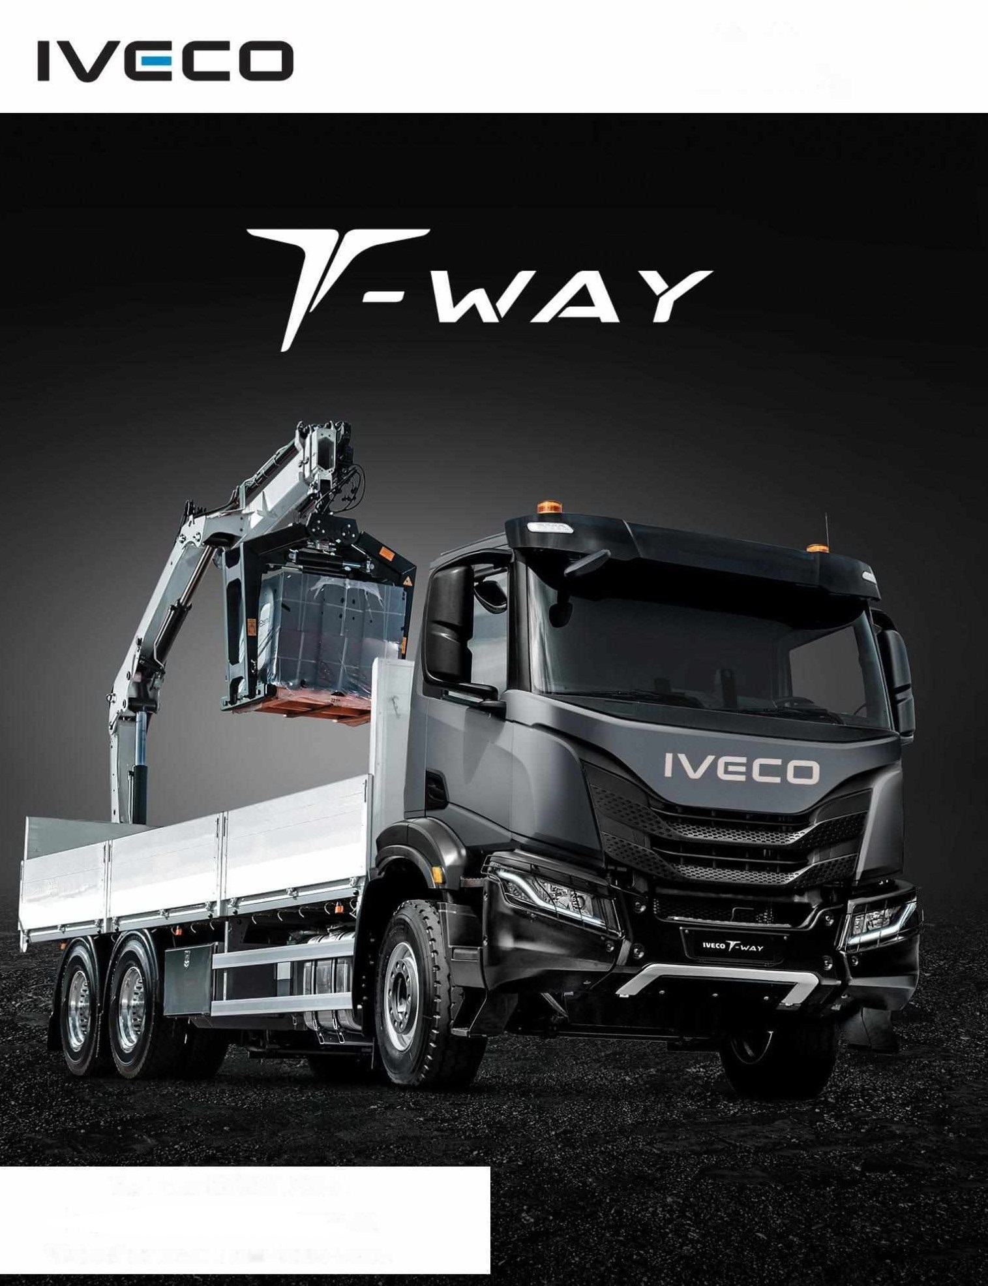

Rigid Chassi AD380T43H - E5 – SVKE - 6x4 (Long Chassis)





Rear Axle Ton 26 ﻃﻦ

اﻟﻤﺤﻮر الأﻣﺎ يم

ﻃﻦ

8

Ton

Front Axle

**اﻟﺤﻤﻮلات**

**Weights**

اﻟﺤﻤﻮﻟﺔ الإﺟﻤﺎﻟيﺔ ﻃﻦ 34 Ton GVW

اﻟﻤﺤﻮر اﻟﺨﻠ . يف

اﻟﺤﻤﻮﻟﺔ اﻟﺼﺎﻓيﺔ ﻃﻦ 24 Ton Payload Net

**Dimensions الأبﻌﺎد**

ﻣﺤﻮر اﻟﻌﺠلات ﻣﻢ 4,500 mm Base Wheel

Overall Length mm 9,102 ﻣﻢ يل الإﺟﻤﺎ اﻟﻄﻮل

Cargo Length mm 7,217 ﻣﻢ اﻟﺼﻨﺪوق ﻃﻮل

**Engine اﻟﻤﺤﺮك**

Model Iveco Cursor 13 F3HGE611W*F اﻟﻤﻮديﻞ

No. Of Cylinders 6

Total Displacement Litres 12,88

ﻋﺪد الأﺳﻄﻮاﻧﺎت

اﻟﺴﻌﺔ ﻟ :ت

Max. Power 430 HP (316 KW) @ 1,900 rpm اﻟﻘﺼﻮى اﻟﻘﺪرة

Max. Torque 2,100 Nm/ 214 Kgm @ 1,100 rpm الأﻗص اﻟﻌﺰم

Emission Standard Euro 5 اﻟﻌﺎدم ﻣﻘيﺎس

Fueling system Common Rail - High Pressure اﻟﻮﻗﻮد ﻣﻨﻈﻮﻣﺔ

**Transmission**

**ﻧﺎﻗﻞ اﻟﺤﺮﻛﺔ**

Type Automated

اﻟﻨوع أوﺗﻮﻣﺎﺗي يك

Model ZF 16TX 2240 TO اﻟﻤﻮديﻞ

No. Of Shifts 16 Forward + 2 Reverse

|  |  |  |  |
| --- | --- | --- | --- |
| Clutch | Single dry plate (17’’) 430 mm | ﻗﺮص ﻣﻔﺮد ﺟﺎف ("17) 430 ﻣﻠﻢ | اﻟﻘﺎبﺾ |
| **Brakes** |  |  | **اﻟﻔﺮاﻣﻞ** |
| Type | 2 independent pneumatic circuits | ﺗﻌﻤﻞ ﻋﻦ ﻃريﻖ ﺧﻄ .ي ﻫﻮاء ﻣﻨﻔﺼﻠ .ي | اﻟﻨوع |

16 ﻟلأﻣﺎم + 2 سرﻋﺔ ﻟﻠﺨﻠﻒ

ﻋﺪد اﻟﻨﺎﻗلات

Axles Front & Rear Drums E.B.S. + B.A.S.

Engine Brake Turbo Decompression Brake تبﻮ اﻟﺘ ﺿﻐﻂ ﺧلال ﻣﻦ ﺗﻌﻤﻞ اﻟﻤﺤﺮك ﻓﺮاﻣﻞ

ﻃﻨﺎﺑ ت . يف الأﻣﺎم واﻟﺨﻠﻒ

اﻟﻤﺤﺎور

Parking Brake Mechanical Spring Cylinder ﻣيكﺎﻧيﮑيﺎ ﺗﻌﻤﻞ اﻟيﺪ ﻓﺮاﻣﻞ

**Chassis اﻟﺸﺎﺳيﮧ**

Suspension Type Front Reinforced Parabolic

Rear Multi-leaf Spring 13 Leaps

ﻧﻮابﺾ ورﻗيﺔ ﻣﺪﻣﺠﺔ . يف الأﻣﺎم ﻧﻮابﺾ ورﻗيﺔ .ف اﻟﺨﻠﻒ

ﻧوع اﻟﺘﻌﻠﻴﻖ

الاﻃﺎرات 315/80R22,5 (10+1) Tires

Ad Blue Tank

60 Liters

60 ﻟ :ت

ﺧﺰان اﻟﻴﻮريﺎ

Fuel Tank 550 liters

550 ﻟ :ت

ﺧﺰان اﻟﻮﻗﻮد

Batteries 2X12 V / 220 Ah, With Battery Switch

**Cab**

**اﻟكﺎﺑيﻨﺔ**

2x12 ﻓﻮﻟﺖ / أﻣﺒ ت ﻣﻊ ﻣﻔﺘﺎح اﻟبﻄﺎريﺔ

اﻟبﻄﺎريﺎت

كﺎﺑيﻨﺔ ﻣﻔﺮدة Cab Day

Sun visor - Front mirror

ﺣﺎﺟﺐ اﻟﺸﻤﺲ - ﻣﺮآة أﻣﺎﻣيﺔ

Radio with Bluetooth and USB

ﻧﻈﺎم اﻧﺬار ﻋﻨﺪ اﻟﺮﺟوع ﻟﻠﺨﻠﻒ Alarm Reverse

رادﻳﻮ ﻣﺰود بﺎﻟبﻠﻮﺗﻮث و ﻣﻨﻔﺬ ﻳﻮ اس . يب